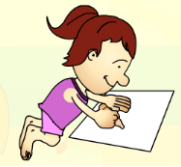draw…………………………………………………………………………………………………………………………………………………...………………………………………………………………............

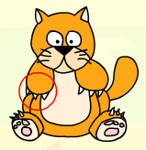claw…………………………………………………………………...………………………………………………………………………………………………………………………………………………….......

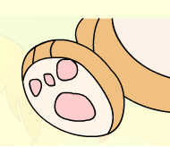paw……………………………………………………………………………………………………………………………………………………………………………………………………………………....

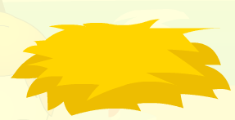straw…………………………………………………………………………………………………………………………………………………………………………………………………………………………

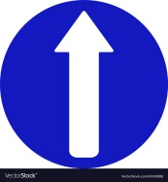go straight……………………………………………………………

……………………………………………………………………………………………………………………………………………………

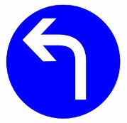Turn left…………………………………………………………………

……………………………………………………………………………………………………………………………………………………

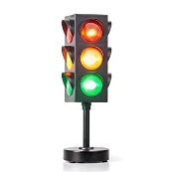Traffic light ………………………………………………………………….....................................................................................................................................................................................................................................................

What did Pat do when he was sick?

🡪 He stayed at home. He read books and listened to music.

……………………………………………………………………………………………………………………………………………………………………………………………………………………………………………………………………………………………………………………………………………………………………………………………………………………………………………………………………………………………………………....

☺☺☺Dặn dò, học sinh copy mỗi từ 3 dòng ☺☺☺